* 1. **Introduction to Project Theme:**

The Web Application for Fitness Center is a web-based application developed to manage the daily operations of a fitness center and its supplement-selling activities in an efficient and organized manner. The project is designed for Muscle Villa Gym that provides professional training services along with the sale of certified fitness supplements to its members.

The theme of this project focuses on the digital transformation of fitness center operations through automation and efficient data handling. The system integrates staff management, supplier management, client management, membership management, supplement inventory control and client purchase tracking.

The core objective of the project is to replace manual record-keeping with a structured, database system that stores all information in tabular format. This ensures quick access to data, better monitoring of gym activities. Additionally, the system emphasizes user convenience and administrative control, allowing smooth interaction for clients while providing complete authority and oversight to the administrator.

Overall, the Web Application for Fitness Center helps in maintaining accurate records, improving operational efficiency, and enhancing the quality of services provided to members.

* 1. **Working of System:**

The Web Application for Fitness Center works through a role based access mechanism involving two types of users: Admin and Client.

Admin Side Working

The admin logs in using authorized access. After successful login the admin can perform the following operations:

* Add, view, update, and delete staff details.
* Manage supplier information.
* Handle product inventory such as fitness supplements.
* View client registration and membership details.
* Track product purchases and generate bills.
* View feedback submitted by clients.

The admin can also generate various reports such as staff report, supplier report, inventory report, membership report, and purchase report.

Client Side Working:

Client registers themselves through the user panel. After successful registration client can:

* Choose a gym membership plan.
* View available supplements.
* Purchase products.
* Submit feedback to the gym.

All the data entered by users and the admin is stored securely in a SQL based database and displayed in tabular format. The system processes user requests efficiently and provides accurate results in real time.

* 1. **Need & Scope of Proposed System:**
* Manual handling of fitness center operations is time-consuming and can cause errors.
* Managing large volumes of records such as members, staff, suppliers, inventory, and purchases becomes difficult in the existing system.
* High chances of data duplication and inconsistency in manual record keeping.
* There is a need to manage all the activities of gym efficiently.
* The proposed system provides structured storage of data in an SQL-based database using tabular format.
* It enables efficient management of member registrations and membership plans.
* The system maintains staff and supplier details in an organized manner.
* It helps in tracking supplement inventory and monitoring product sales.
* The system supports generation of various administrative reports for better decision-making.
* Client feedback collection is included to improve service quality.
* The application ensures better transparency, control and operational efficiency for the administrator.
* The scope of the system can be extended in the future to include online payment integration, attendance tracking, mobile application support and advanced analytics.
  1. **Organization Profile:**

Muscle Villa is a fitness center that aims to promote a healthy lifestyle through professional training programs and quality fitness supplements.

The Gym was started in year 2013 and the owner of the gym is Mr. Aslam Shaikh. He is professional bodybuilder and started a bodybuilding career in year 2000. The gym has 3 experienced trainers Mr. Yasir Bepari, Mr. Shoaib Shaikh, Mr. Sakib Sayyad. They provide best training to the members in the gym.

The gym offers fitness goals such as weight loss, muscle gain, and overall fitness for bodybuilding as well as sports athletes and also train members for police selection fitness exams.

In addition to training services, Muscle Villa also sells certified and branded fitness supplements of brand Oxybuild to its members.

The gym focuses on:

* Customer satisfaction
* Quality products
* Professional training environment

**2.1 Site Map :**

**2.2 Data Dictionary**

|  |  |  |  |  |
| --- | --- | --- | --- | --- |
| **Sr. No.** | **Fields** | **Data type** | **size** | **Description** |
| 1 | Name | Varchar | 100 | To store the name |
| 2 | Contact number | Varchar | 15 | To store the contact number |
| 3 | Email Id | Varchar | 100 | To store the email id |
| 4 | Comment | Varchar |  | To store the comment |
| 5 | Rating | Integer |  | To store the given rating |

**3.1 Web Page Design :**

**Home**

**index.html**

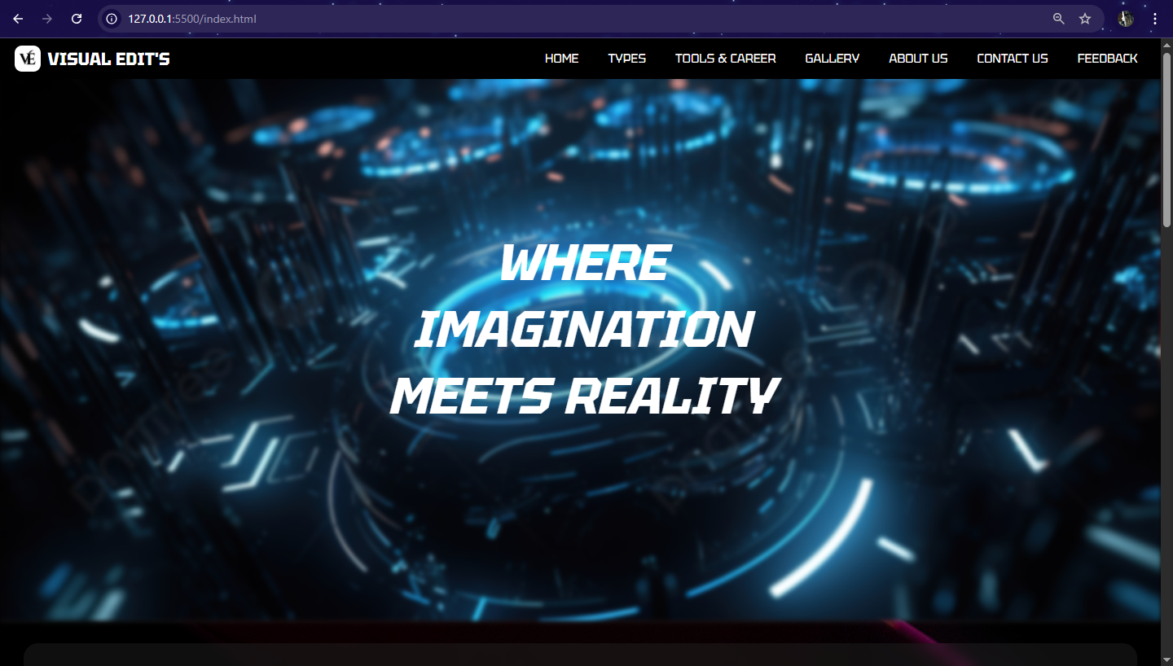

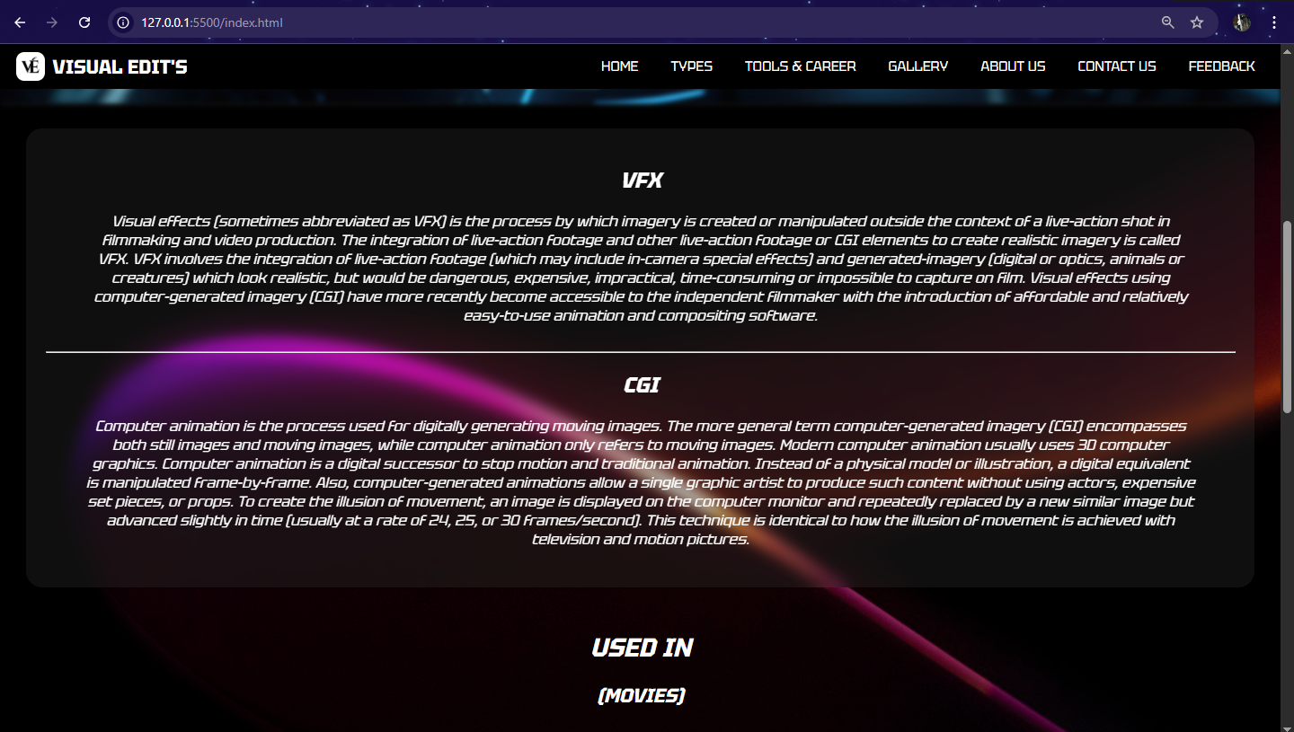

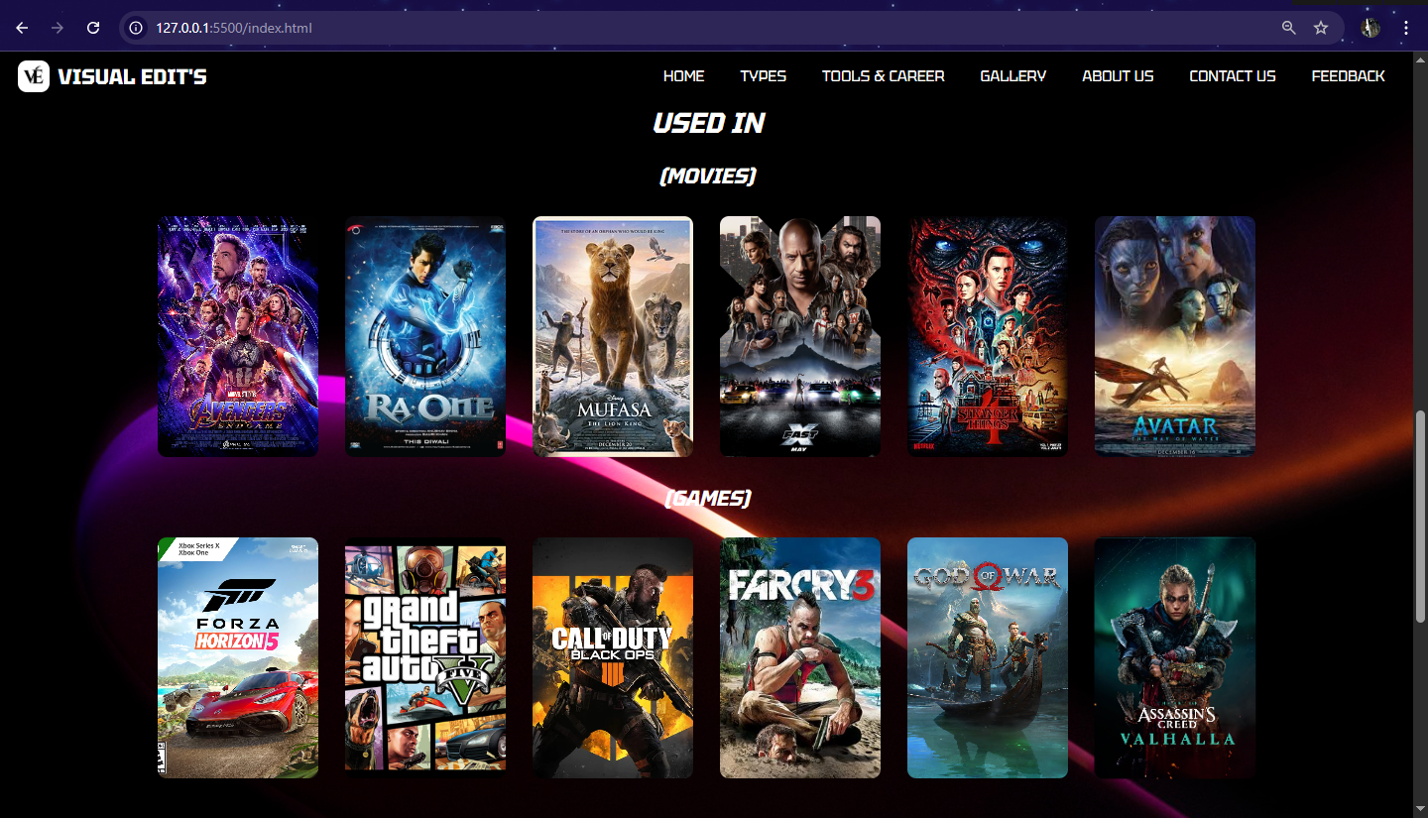

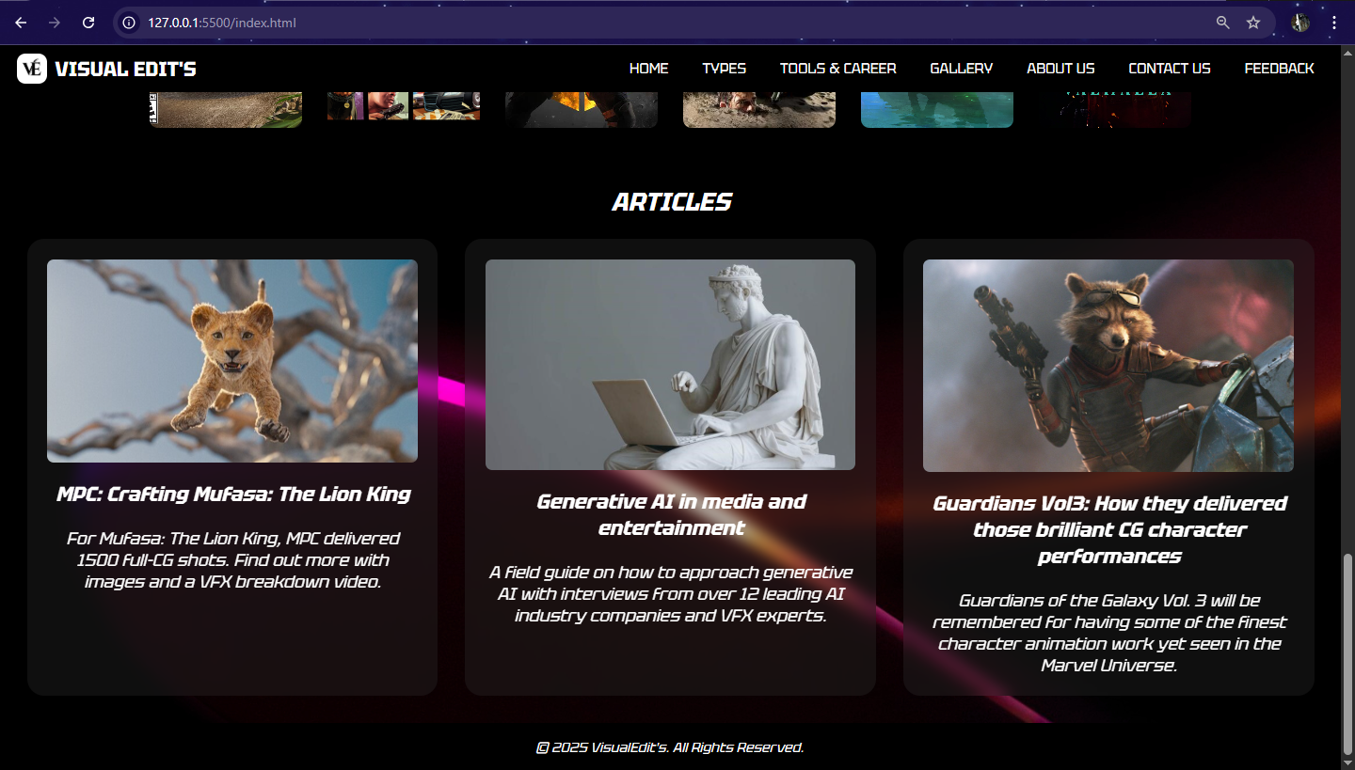

**Code: HTML & CSS**

<!DOCTYPE html>

<html lang="en">

<head>

<meta charset="UTF-8">

<meta name="viewport" content="width=device-width, initial-scale=1.0">

<title>Visual Edit's</title>

<link rel="preconnect" href="https://fonts.googleapis.com">

<link rel="preconnect" href="https://fonts.gstatic.com" crossorigin>

<link href="https://fonts.googleapis.com/css2?family=Tektur:wght@400..900&display=swap" rel="stylesheet">

<style>

body {

margin: 0;

background: url('bg.jpg') no-repeat center center fixed;

font-family: 'Tektur';

text-align: center;

background-color: #181818;

color: #fff;

scroll-behavior: smooth;

}

header {

display: flex;

justify-content: space-between;

align-items: center;

padding: 10px 20px;

position: fixed;

width: 98%;

z-index: 10;

background-color: #000000;

}

.logo {

display: flex;

align-items: center;

justify-content: center;

}

.logo span {

font-size: 24px;

font-weight: bold;

margin-left: 10px;

}

.logo img {

height: 35px;

width: auto;

border-radius: 10px;

}

nav ul {

list-style: none;

padding: 0;

margin: 0;

display: flex;

}

nav ul li {

margin: 0 10px;

}

nav ul li a {

font-size: 17px;

text-decoration: none;

color: #fff;

background: #000000;

padding: 5px 10px;

border-radius: 7px;

}

nav ul li a:hover {

background: #fffefe;

color: #0004ff;

}

.hero {

height: 85vh;

display: flex;

justify-content: center;

align-items: center;

color: white;

text-align: center;

position: relative;

}

.hero::before {

content: '';

position: absolute;

top: 0;

left: 0;

width: 100%;

height: 100%;

background: url('vfx4.jpg') no-repeat center center/cover;

box-shadow: 0 2px 2px rgba(255, 255, 255, 0.1);

filter: blur(3px);

z-index: -1;

}

.overlay h1 {

font-size: 70px;

}

.info {

font-size: 18px;

}

.info p {

padding-left: 50px;

padding-right: 50px;

}

.gallery {

display: flex;

justify-content: center;

align-items: center;

gap: 30px;

padding: 10px;

flex-wrap: wrap;

}

.gallery img {

width: 180px;

height: 270px;

object-fit: cover;

border-radius: 10px;

transition: transform 0.3s ease-in-out;

}

.gallery img:hover {

transform: scale(1.1);

}

.article {

font-size: 20px;

}

.grid {

display: grid;

grid-template-columns: repeat(auto-fit, minmax(300px, 1fr));

gap: 2rem;

}

section {

padding: 2rem;

}

.card {

background: rgba(43, 43, 43, 0.336);

padding: 1.5rem;

border-radius: 20px;

box-shadow: 0 4px 6px rgba(0, 0, 0, 0.1);

backdrop-filter: blur(8px);

transition: transform 0.3s ease-in-out;

}

.card:hover {

transform: scale(1.05);

}

.card h3 {

margin-top: 0;

font-size: 1.5rem;

}

.card p {

margin: 1rem 0 0;

}

.card img {

width: 100%;

border-radius: 8px;

margin-bottom: 1rem;

}

footer {

padding: 3px;

background-color: black;

position: relative;

bottom: 0;

width: 99.5%;

}

</style>

</head>

<body>

<header>

<div class="logo">

<img src="LOGO.png" alt="Visual Edit's Logo">

<span>VISUAL EDIT'S</span>

</div>

<nav>

<ul>

<li><a href="index.html">HOME</a></li>

<li><a href="types.html">TYPES</a></li>

<li><a href="tools&career.html">TOOLS & CAREER</a></li>

<li><a href="gallery.html">GALLERY</a></li>

<li><a href="about.html">ABOUT US</a></li>

<li><a href="contact.html">CONTACT US</a></li>

<li><a href="feedback.php">FEEDBACK</a></li>

</ul>

</nav>

</header>

<section class="hero">

<div class="overlay">

<h1><i>WHERE<br>IMAGINATION<br>MEETS REALITY</h1>

</div>

</section>

<section>

<div class="info">

<div class="grid">

<div class="card">

<h1><i>VFX </i></h1>

<p><i>Visual effects (sometimes abbreviated as VFX) is the process by which imagery is created or manipulated outside the context of a live-action shot in filmmaking and video production. ....</i></p>

<br><hr>

<h1><i>CGI</i></h1>

<p><i>Computer animation is the process used for digitally generating moving images....</i></p><br>

</div>

</div>

</div>

</section>

<h1>USED IN</h1>

<h2>(MOVIES)</h2>

<div class="gallery">

<img src="avengers.jpg" alt="Avengers: Endgame">

<img src="raone.jpg" alt="Ra.One">

<img src="mufasa.jpeg" alt="Mufasa: The Lion King">

<img src="FastX.jpg" alt="Fast X">

<img src="stranger.jpg" alt="Stranger_Things_season_4">

<img src="avatar.jpeg" alt="Avatar">

</div>

<h2>(GAMES)</h2>

<div class="gallery">

<img src="froza.webp" alt="Forza Horizon 5">

<img src="GTAV.png" alt="GTA V">

<img src="COD.webp" alt="Call of Duty: Black Ops III">

<img src="farcry.jpg" alt="Far Cry 3">

<img src="GOW.jpeg" alt="God of War">

<img src="vanhalla.jpg" alt="Assassin's Creed Valhalla">

</div>

<section>

<div class="article">

<h1><i>ARTICLES </i></h1>

<div class="grid">

<div class="card">

<img src="article1.jpeg" alt="article 1">

<h3>MPC: Crafting Mufasa: The Lion King</h3>

<p>For Mufasa: The Lion King, MPC delivered 1500 full-CG shots. Find out more with images and a VFX breakdown video.</p>

</div>

<div class="card">

<img src="article2.jpeg" alt="article 2">

<h3>Generative AI in media and entertainment</h3>

<p>A field guide on how to approach generative AI with interviews from over 12 leading AI industry companies and VFX experts.</p>

</div>

<div class="card">

<img src="article3.jpg" alt="article 3">

<h3>Guardians Vol3: How they delivered those brilliant CG character performances</h3>

<p>Guardians of the Galaxy Vol. 3 will be remembered for having some of the finest character animation work yet seen in the Marvel Universe.</p>

</div>

</div>

</div>

</section>

<footer>

<p>&copy 2025 VisualEdit's. All Rights Reserved.</p>

</footer>

</body>

</html>

**Types**

**types.html**

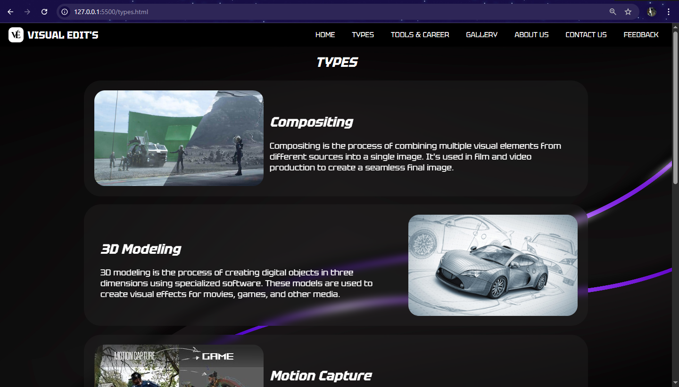

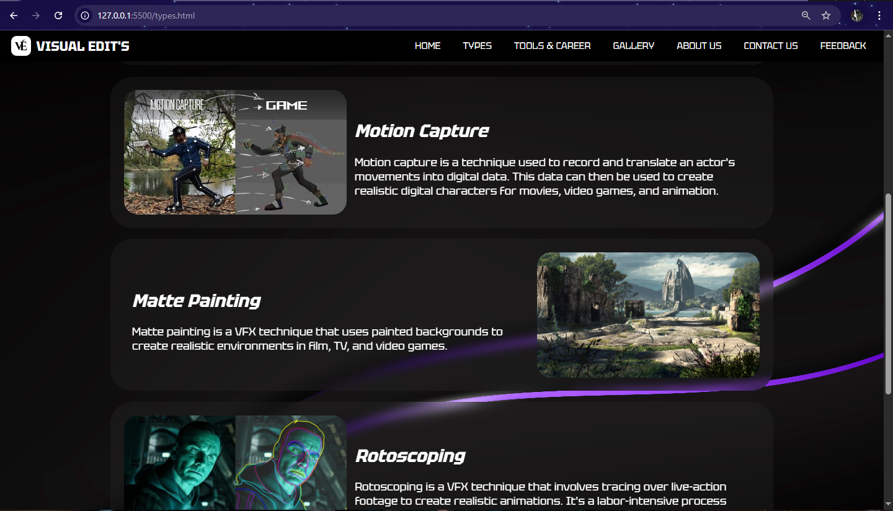

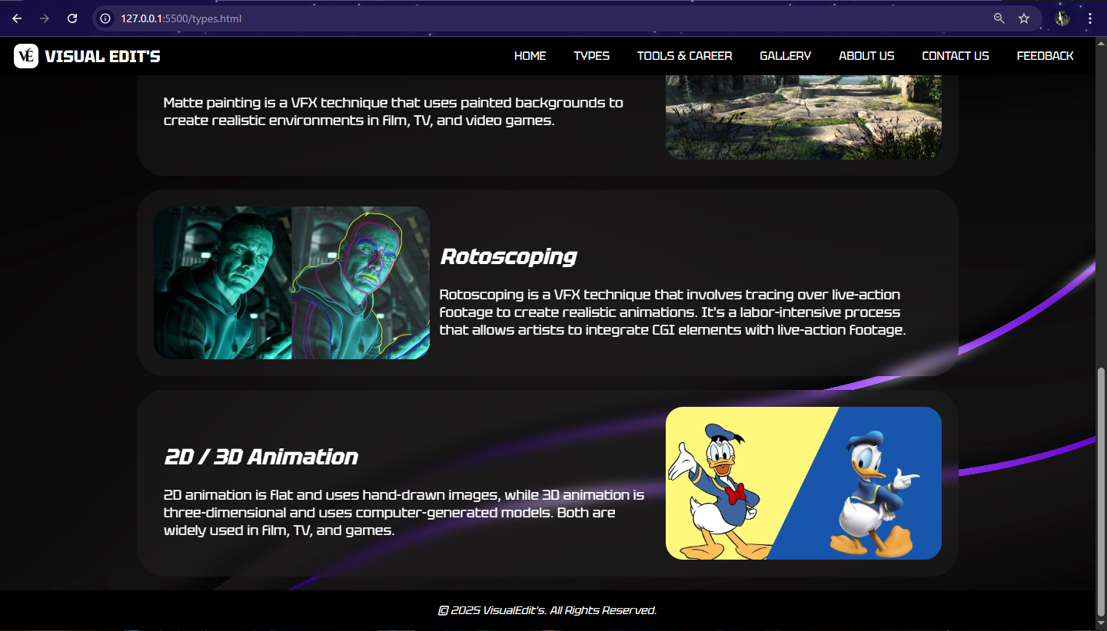

**Code: HTML & CSS**

<!DOCTYPE html>

<html lang="en">

<head>

    <meta charset="UTF-8">

    <meta name="viewport" content="width=device-width, initial-scale=1.0">

    <title>Types</title>

    <link rel="preconnect" href="https://fonts.googleapis.com">

    <link rel="preconnect" href="https://fonts.gstatic.com" crossorigin>

    <link href="https://fonts.googleapis.com/css2?family=Tektur:wght@400..900&display=swap" rel="stylesheet">

    <style>

        body {

            margin: 0;

            padding: 0;

            background: url('bg9.jpg') no-repeat center center fixed;

            font-family: 'Tektur';

            background-size: cover;

            text-align: center;

            background-color: #181818;

            color: #fff;

            scroll-behavior: smooth;

        }

        header {

            display: flex;

            justify-content: space-between;

            align-items: center;

            padding: 10px 20px;

            top: 0%;

            position: fixed;

            width: 98%;

            z-index: 10;

            background-color: #000000;

        }

        .logo {

            display: flex;

            align-items: center;

            justify-content: center;

        }

        .logo span {

            font-size: 24px;

            font-weight: bold;

            margin-left: 10px;

        }

        .logo img {

            height: 35px;

            width: auto;

            border-radius: 10px;

        }

        nav ul {

            list-style: none;

            padding: 0;

            margin: 0;

            display: flex;

        }

        nav ul li {

            margin: 0 10px;

        }

        nav ul li a {

            font-size: 17px;

            text-decoration: none;

            color: #fff;

            background: #000000;

            padding: 5px 10px;

            border-radius: 7px;

        }

        nav ul li a:hover {

            background: #fffefe;

            color: #0004ff;

        }

        .type h1 {

            padding-top: 50px;

        }

        .container {

            width: 75%;

            margin: 20px auto;

        }

        .box {

            background: rgba(43, 43, 43, 0.3);

            display: flex;

            align-items: center;

            margin-bottom: 20px;

            padding: 1.5rem;

            border-radius: 40px;

            backdrop-filter: blur(8px);

            transition: transform 0.3s ease-in-out;

        }

        .box:hover {

            transform: scale(1.05);

        }

        .box img {

            width: 35%;

            height: auto;

            border-radius: 25px;

        }

        .text {

            text-align: left;

            padding: 0 15px;

            color: white;

        }

        .text h2 {

            margin: 0;

            font-size: 18px;

        }

        .text p {

            font-size: 20px;

            margin: 5px 0 0;

        }

        footer {

            padding: 3px;

            background-color: black;

            position: relative;

            bottom: 0;

            width: 99.5%;

        }

    </style>

</head>

<body>

    <header>

        <div class="logo">

            <img src="LOGO.png" alt="Visual Edit's Logo">

            <span>VISUAL EDIT'S</span>

        </div>

        <nav>

            <ul>

                <li><a href="index.html">HOME</a></li>

                <li><a href="types.html">TYPES</a></li>

                <li><a href="tools&career.html">TOOLS & CAREER</a></li>

                <li><a href="gallery.html">GALLERY</a></li>

                <li><a href="about.html">ABOUT US</a></li>

                <li><a href="contact.html">CONTACT US</a></li>

                <li><a href="feedback.php">FEEDBACK</a></li>

            </ul>

        </nav>

    </header>

    <div class="container">

        <div class="type">

            <h1><i>TYPES</i></h1>

        </div>

        <div class="box">

            <img src="compositing.jpg" alt="Compositing">

            <div class="text">

                <h1><i>Compositing</i></h1>

                <p>Compositing is the process of combining multiple visual elements from different sources into a single image. It's used in film and video production to create a seamless final image.</p></div>

        </div>

        <div class="box">

            <div class="text">

                <h1><i>3D Modeling</i></h1>

                <p>3D modeling is the process of creating digital objects in three dimensions using specialized software. These models are used to create visual effects for movies, games, and other media.</p></div>

            <img src="modeling.jpg" alt="Modeling">

        </div>

        <div class="box">

            <img src="motion.jpg" alt="Motion Capture">

            <div class="text">

                <h1><i>Motion Capture</i></h1>

                <p>Motion capture is a technique used to record and translate an actor's movements into digital data. This data can then be used to create realistic...</p></div>

        </div>

        <div class="box">

            <div class="text">

                <h1><i>Matte Painting</i></h1>

                <p>Matte painting is a VFX technique that uses painted backgrounds to...</p></div>

            <img src="matte.jpg" alt="Matte Painting">

        </div>

        <div class="box">

            <img src="Rotoscoping.jpg" alt="Rotoscoping">

            <div class="text">

                <h1><i>Rotoscoping</i></h1>

                <p>Rotoscoping is a VFX technique that involves tracing over live-action....</p></div>

        </div>

        <div class="box">

            <div class="text">

                <h1><i>2D / 3D Animation</i></h1>

                <p>2D animation is flat and uses hand- drawn...</p></div>

            <img src="animation.webp" alt="Animation">

        </div>

    </div>

    <footer>

        <p><i>&copy 2025 VisualEdit's. All Rights Reserved.</i></p>

    </footer>

</body>

</html>

**Tools & Carrer**

**tools&career.html**

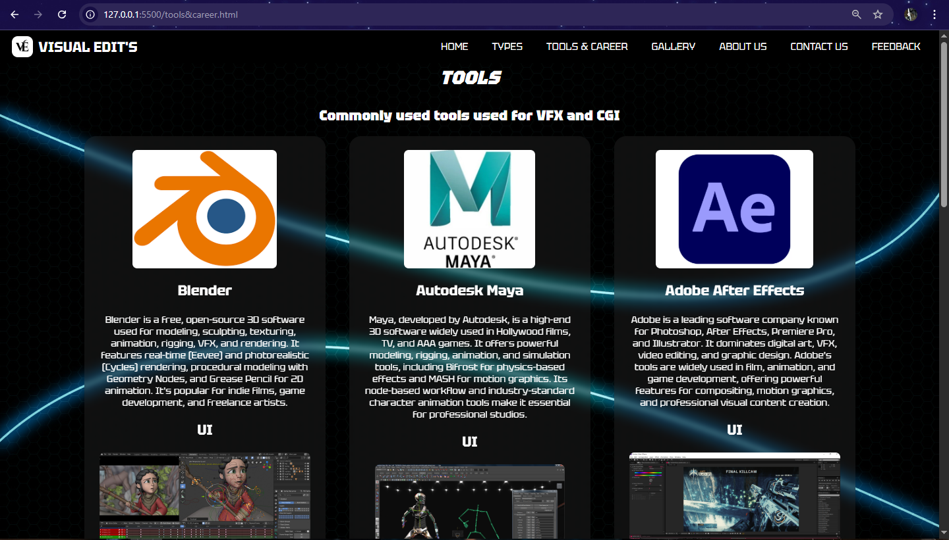

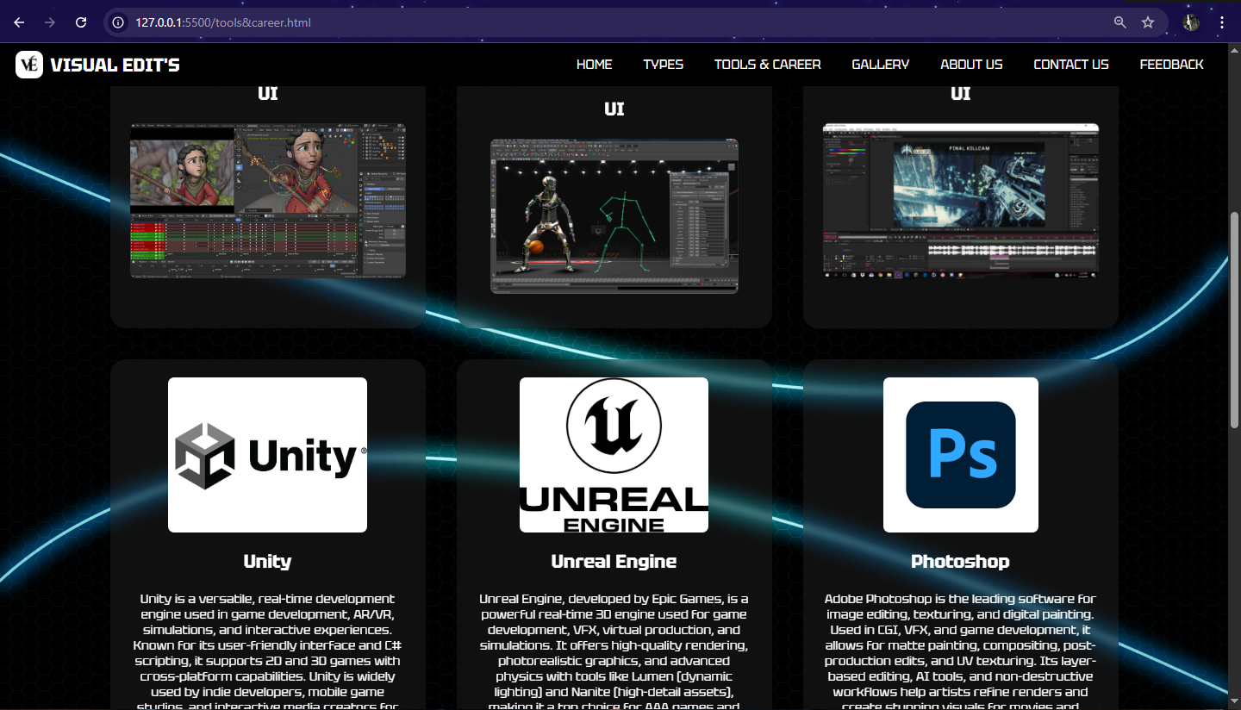

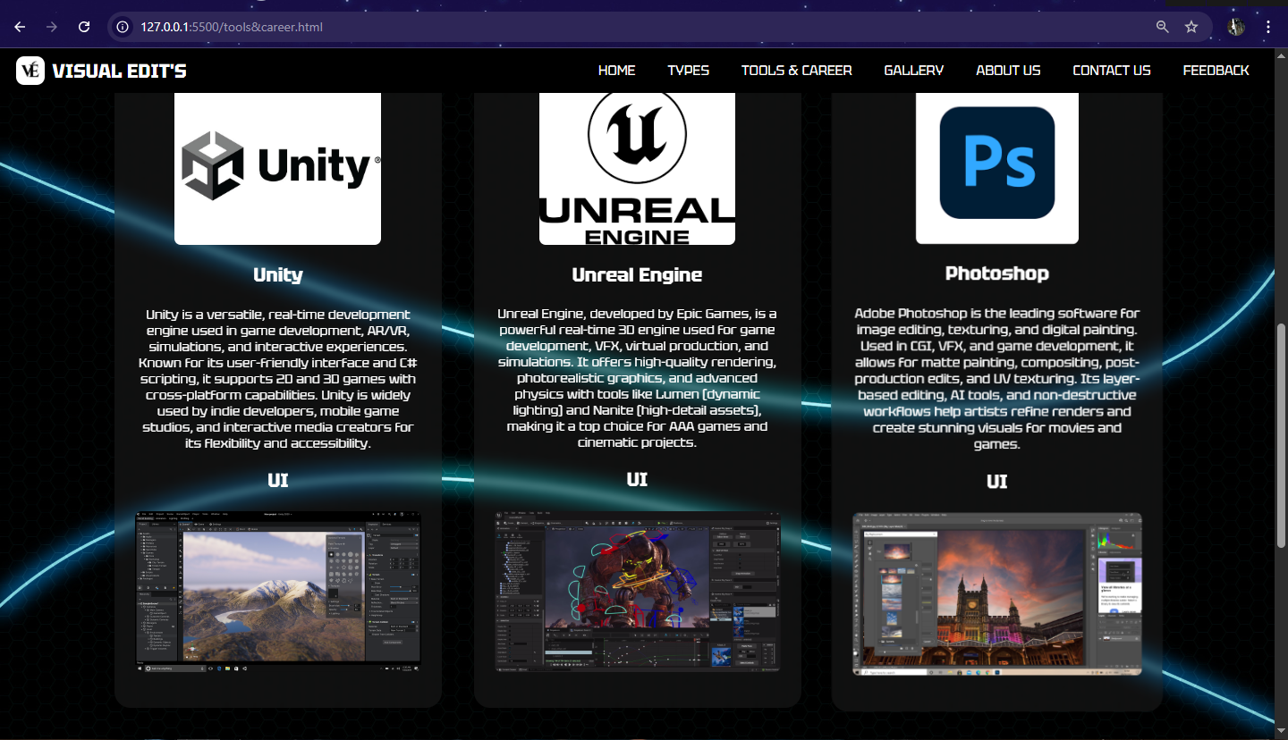

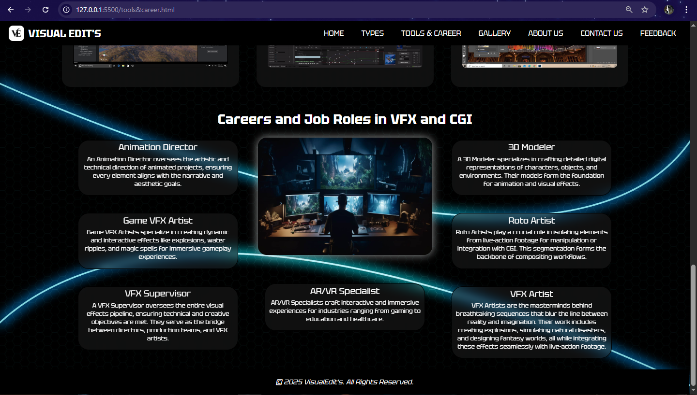

**Code: HTML & CSS**

<!DOCTYPE html>

<html>

<head>

    <meta charset="UTF-8">

    <meta name="viewport" content="width=device-width,initial-scale=1.0">

    <title>Tools&Career</title>

    <link rel="preconnect"href="https://fonts.googleapis.com">

    <link rel="preconnect" href="https://fonts.gstatic.com" \ crossorigin>

    <link href="https://fonts.googleapis.com/css2?family=Tektur:wght@400..900&display=swap" rel="stylesheet">

    <style>

        body {

            margin: 0;

            background: url('bg3.jpg') no-repeat center center fixed;

            background-size: cover;

            font-family: 'Tektur';

            text-align: center;

            background-color: #181818;

            color: #fff;

            scroll-behavior: smooth;

        }

        header {

            display: flex;

            justify-content: space-between;

            align-items: center;

            padding: 10px 20px;

            position: fixed;

            width: 98%;

            z-index: 10;

            background-color: #000000;

        }

        .logo {

            display: flex;

            align-items: center;

            justify-content: center;

        }

        .logo span {

            font-size: 24px;

            font-weight: bold;

            margin-left: 10px;

        }

        .logo img {

            height: 35px;

            width: auto;

            border-radius: 10px;

        }

        nav ul {

            list-style: none;

            padding: 0;

            margin: 0;

            display: flex;

        }

        nav ul li {

            margin: 0 10px;

        }

        nav ul li a {

            font-size: 17px;

            text-decoration: none;

            color: #fff;

            background: #000000;

            padding: 5px 10px;

            border-radius: 7px;

        }

        nav ul li a:hover {

            background: #fffefe;

            color: #0004ff;

        }

        .grid {

            display: grid;

            grid-template-columns: repeat(3, 1fr);

            gap: 2.5rem;

        }

        section {

            padding: 2rem;

            margin: 0 auto;

            max-width: 1300px;

        }

        .card {

            background: rgba(43, 43, 43, 0.336);

            padding: 1.5rem;

            border-radius: 20px;

            box-shadow: 0 4px 6px rgba(0, 0, 0, 0.1);

            backdrop-filter: blur(5px);

            transition: transform 0.3s ease-in-out;

        }

        .card:hover {

            transform: scale(1.05);

        }

        .card h3 {

            margin-top: 0;

            font-size: 1.5rem;

        }

        .card p {

            margin: 1rem 0 0;

        }

        .card img {

            height: 200px;

            width: auto;

            border-radius: 8px;

            margin-bottom: 1rem;

        }

        h1 {

            font-size: 32px;

            font-weight: bold;

        }

        .container {

            display: flex;

            justify-content: center;

            align-items: start;

            flex-wrap: wrap;

            margin: 20px 0;

        }

        .left,

        .right {

            display: flex;

            flex-direction: column;

            gap: 30px;

        }

        .center {

            display: flex;

            flex-direction: column;

            align-items: center;

            margin: 0 40px;

        }

        .image {

            width: 400px;

            height: 270px;

            border-radius: 20px;

            box-shadow: 0px 0px 20px rgba(193, 196, 196, 0.8);

            transition: transform 0.2s ease-in-out;

        }

        .image:hover {

            transform: scale(1.05);

        }

        .role {

            font-size: 20px;

            padding: 3px 8px;

            border-radius: 25px;

            background: rgba(43, 43, 43, 0.336);

            display: inline-block;

            margin: 5px;

            border: 1px solid black;

            box-shadow: 0 4px 6px rgba(0, 0, 0, 0.1);

            backdrop-filter: blur(9px);

            transition: transform 0.3s ease-in-out;

        }

        .role:hover {

            transform: scale(1.05);

        }

        .animation-director {

            top: 0;

        }

        .info {

            font-size: 14px;

            color: white;

            margin-top: 5px;

            max-width: 350px;

        }

        footer {

            padding: 3px;

            background-color: black;

            position: relative;

            bottom: 0;

            width: 99.5%;

        }

    </style>

</head>

<body>

    <header>

        <div class="logo">

            <img src="LOGO.png" alt="Visual Edit's Logo">

            <span>VISUAL EDIT'S</span>

        </div>

        <nav>

            <ul>

                <li><a href="index.html">HOME</a></li>

                <li><a href="types.html">TYPES</a></li>

                <li><a href="tools&career.html">TOOLS & CAREER</a></li>

                <li><a href="gallery.html">GALLERY</a></li>

                <li><a href="about.html">ABOUT US</a></li>

                <li><a href="contact.html">CONTACT US</a></li>

                <li><a href="feedback.php">FEEDBACK</a></li>

            </ul>

        </nav>

    </header>

    <section>

        <div class="tools">

            <h1><b><i>

                        <centre> TOOLS</centre>

                    </i></b></h1>

            <h2><b>

                    <centre>Commonly used tools used for VFX and CGI </centre>

                </b></h2>

        </div>

        <div class="grid">

            <div class="card">

                <img src="blenderlogo.png">

                <h3>Blender</h3>

                <p>Blender is a free, open-source 3D software used for modeling, sculpting, texturing, animation, rigging, VFX, and rendering...p><br>

                <h3>UI</h3>

                <img src="blender.jpg">

            </div>

            <div class="card">

                <img src="mayalogo.jpg">

                <h3> Autodesk Maya</h3>

                <p>Maya, developed by Autodesk, is a high-end 3D software widely used in Hollywood films, TV, and AAA games...</p><br>

                <h3>UI</h3>

                <img src="maya.jpg">

            </div>

            <div class="card">

                <img src="aftereffectslogo.png">

                <h3>Adobe After Effects</h3>

                <p>Adobe is a leading software company known for Photoshop, After Effects, Premiere Pro, and Illustrator....</p><br>

                <h3>UI</h3>

                <img src="after effects.png">

            </div>

            <div class="card">

                <img src="unitylogo.jpg">

                <h3>Unity</h3>

                <p> Unity is a versatile, real-time development engine used in game development, AR/VR, simulations, and interactive experiences...</p><br>

                <h3>UI</h3>

                <img src="unity.png">

            </div>

            <div class="card">

                <img src="unreallogo.png">

                <h3> Unreal Engine</h3>

                <p> Unreal Engine, developed by Epic Games, is a powerful real-time 3D engine used for game development, VFX, virtual production, and simulations...</p><br>

                <h3>UI</h3>

                <img src="unreal.jpg">

            </div>

            <div class="card">

                <img src="photoshoplogo.png">

                <h3>Photoshop</h3>

                <p>Adobe Photoshop is the leading software for image editing, texturing, and digital painting. .</p><br>

                <h3>UI</h3>

                <img src="photoshop.jpg">

            </div>

        </div>

        </div>

    </section>

    <h1>Careers and Job Roles in VFX and CGI</h1>

    <div class="container">

        <div class="left">

            <div class="role animation-director">Animation Director

                <p class="info">An Animation Director oversees the artistic and technical direction of animated projects, ensuring every element aligns with the narrative and aesthetic goals.</p></div>

            <div class="role">Game VFX Artist

                <p class="info">

                    Game VFX Artists specialize in creating dynamic and interactive effects like explosions, water ripples, and magic spells for immersive gameplay experiences.</p></div>

            <div class="role">VFX Supervisor

                <p class="info">A VFX Supervisor oversees the entire visual effects pipeline, ensuring technical and creative objectives are met...</p>

            </div></div>

        <div class="center">

            <img src="career.jpg" alt="VFX Lab" class="image">

            <br><br><br>

            <div class="role">AR/VR Specialist

                <p class="info">AR/VR Specialists craft interactive and immersive experiences for industries ranging from gaming to education and healthcare.</p>

            </div>

        </div>

        <div class="right">

            <div class="role">3D Modeler

                <p class="info">A 3D Modeler specializes in crafting detailed digital representations of characters, objects, and environments...</p> </div>

            <div class="role">Roto Artist

                <p class="info">Roto Artists play a crucial role in isolating elements from live-action footage for manipulation or integration with CGI. This segmentation forms the backbone of compositing workflows.</p></div>

            <div class="role">VFX Artist

                <p class="info">VFX Artists are the masterminds behind breathtaking sequences that blur the line between reality and imagination...</p></div>

        </div>

    </div>

    <footer>

        <p><i>&copy 2025 VisualEdit's. All Rights Reserved.</i></p>

    </footer>

</body>

</html>

**GALLERY**

**gallery.html**

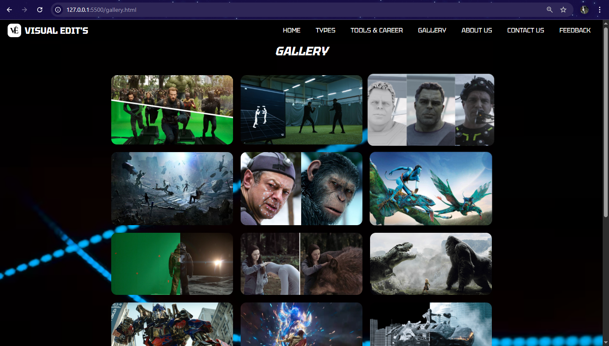

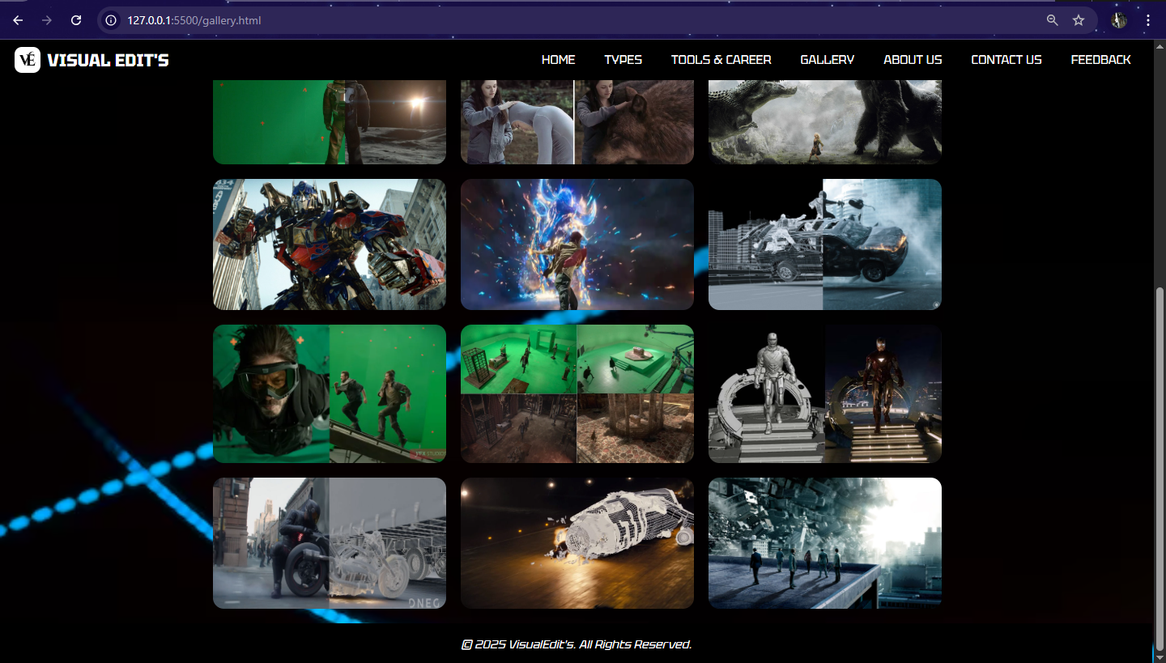

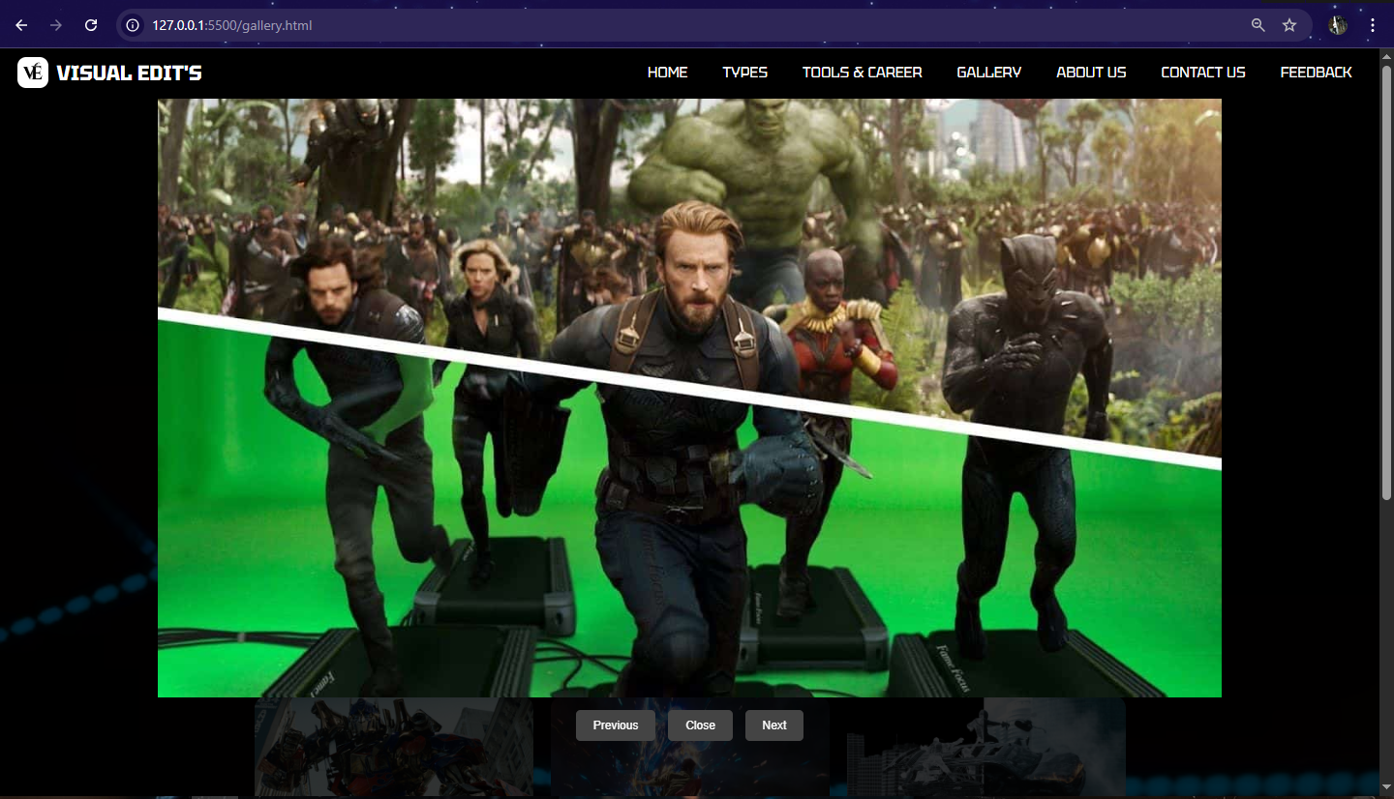

**Code : HTML , CSS & JavaScript**

<!DOCTYPE html>

<html lang="en">

<head>

    <meta charset="UTF-8">

    <meta name="viewport" content="width=device-width,initial-scale=1.0">

    <title>Gallery</title>

    <link rel="preconnect"href="https://fonts.googleapis.com">

    <link rel="preconnect" href="https://fonts.gstatic.com" crossorigin>

    <link href="https://fonts.googleapis.com/css2?family=Tektur:wght@400..900&display=swap" rel="stylesheet">

    <style>

        body {

            margin: 0;

            background: url('bg2.avif') no-repeat center center fixed;

            background-size: cover;

            font-family: 'Tektur';

            text-align: center;

            background-color: #181818;

            color: #fff;

            scroll-behavior: smooth;

        }

        header {

            display: flex;

            justify-content: space-between;

            align-items: center;

            padding: 10px 20px;

            top: 0%;

            position: fixed;

            width: 98%;

            z-index: 10;

            background-color: #000000;

        }

        .logo {

            display: flex;

            align-items: center;

            justify-content: center;

        }

        .logo span {

            font-size: 24px;

            font-weight: bold;

            margin-left: 10px;

        }

        .logo img {

            height: 35px;

            width: auto;

            border-radius: 10px;

        }

        nav ul {

            list-style: none;

            padding: 0;

            margin: 0;

            display: flex;

        }

        nav ul li {

            margin: 0 10px;

        }

        nav ul li a {

            font-size: 17px;

            text-decoration: none;

            color: #fff;

            background: #000000;

            padding: 5px 10px;

            border-radius: 5px;

        }

        nav ul li a:hover {

            background: #fffefe;

            color: #0004ff;

        }

        h1 {

            padding-top: 40px;

        }

        .gallery {

            display: grid;

            grid-template-columns: repeat(3, 1fr);

            gap: 20px;

            padding: 20px;

            max-width: 1000px;

            margin: auto;

        }

        .gallery img {

            width: 100%;

            height: 100%;

            cursor: pointer;

            border-radius: 15px;

            transition: transform 0.3s;

        }

        .gallery img:hover {

            transform: scale(1.05);

        }

        .lightbox {

            display: none;

            position: fixed;

            top: 0;

            left: 0;

            width: 100%;

            height: 100%;

            background: rgba(0, 0, 0, 0.8);

            justify-content: center;

            align-items: center;

            flex-direction: column;

        }

        .lightbox img {

            max-width: 80%;

            max-height: 80%;

        }

        .lightbox .controls {

            margin-top: 10px;

        }

        .lightbox button {

            background: #444;

            color: white;

            border: none;

            padding: 10px 20px;

            margin: 5px;

            cursor: pointer;

            border-radius: 5px;

        }

        footer {

            padding: 3px;

            background-color: black;

            position: relative;

            bottom: 0;

            width: 99.5%;

        }

    </style>

</head>

<body>

    <header>

        <div class="logo">

            <img src="LOGO.png" alt="Visual Edit's Logo">

            <span>VISUAL EDIT'S</span>

        </div>

        <nav>

            <ul>

                <li><a href="index.html">HOME</a></li>

                <li><a href="types.html">TYPES</a></li>

                <li><a href="tools&career.html">TOOLS & CAREER</a></li>

                <li><a href="gallery.html">GALLERY</a></li>

                <li><a href="about.html">ABOUT US</a></li>

                <li><a href="contact.html">CONTACT US</a></li>

                <li><a href="feedback.php">FEEDBACK</a></li>

            </ul>

        </nav>

    </header>

    <h1><i>GALLERY</i></h1>

    <div class="gallery" id="gallery">

        <img src="img1.jpg" alt="Image 1">

        <img src="img2.jpg" alt="Image 2">

        <img src="img3.jpg" alt="Image 3">

        <img src="img4.jpg" alt="Image 4">

        <img src="img5.jpg" alt="Image 5">

        <img src="img6.jpg" alt="Image 6">

        <img src="img7.jpg" alt="Image 7">

        <img src="img8.jpg" alt="Image 8">

        <img src="img9.jpg" alt="Image 9">

        <img src="img10.jpg" alt="Image 10">

        <img src="img11.webp" alt="Image 11">

        <img src="img12.jpg" alt="Image 12">

        <img src="img13.webp" alt="Image 13">

        <img src="img14.jpg" alt="Image 14">

        <img src="img15.avif" alt="Image 15">

        <img src="img16.jpg" alt="Image 16">

        <img src="img17.jpg" alt="Image 17">

        <img src="img18.jpg" alt="Image 18">

    </div>

    <div class="lightbox" id="lightbox">

        <img id="lightbox-img" src="" alt="">

        <div class="controls">

            <button onclick="prevImage()">Previous</button>

            <button onclick="closeLightbox()">Close</button>

            <button onclick="nextImage()">Next</button>

        </div>

    </div>

    <footer>

        <p><i>&copy; 2025 VisualEdit's. All Rights Reserved.</i></p></footer>

    <script>

        let images = document.querySelectorAll('.gallery img');

        let lightbox = document.getElementById('lightbox');

        let lightboxImg = document.getElementById('lightbox-img');

        let currentIndex = 0;

        images.forEach((img, index) => {

            img.addEventListener('click', () => {

                lightbox.style.display = 'flex';

                lightboxImg.src = img.src;

                currentIndex = index;

            });

        });

        function closeLightbox() {

            lightbox.style.display = 'none';

        }

        function prevImage() {

            currentIndex = (currentIndex - 1 + images.length) % images.length;

            lightboxImg.src = images[currentIndex].src;

        }

        function nextImage() {

            currentIndex = (currentIndex + 1) % images.length;

            lightboxImg.src = images[currentIndex].src;

        }

    </script>

</body>

</html>

**ABOUT US**

**about.html**

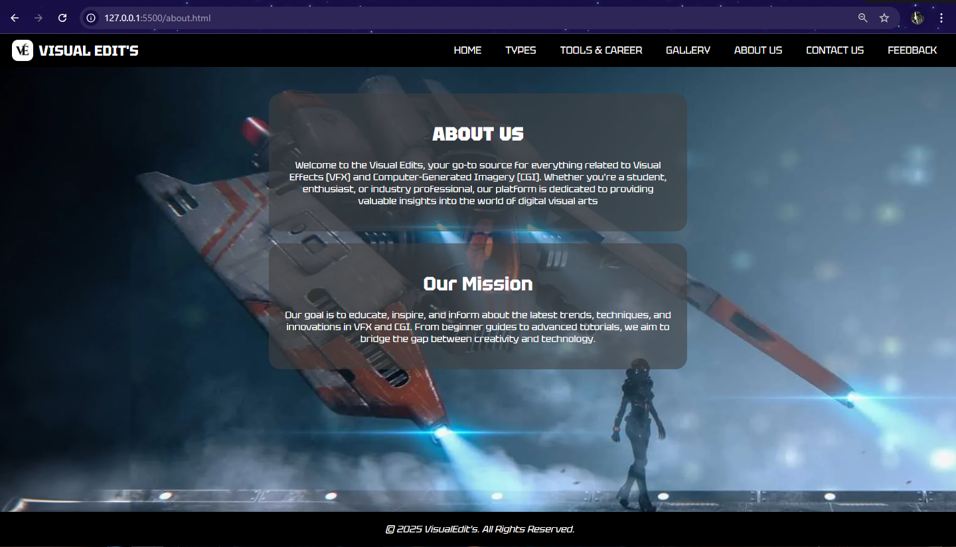

**Code : HTML & CSS**

<!DOCTYPE html>

<html lang="en">

<head>

    <meta charset="UTF-8">

    <meta name="viewport" content="width=device-width,initial-scale=1.0">

    <title>About Us</title>

    <link rel="preconnect" href="https://fonts.googleapis.com">

    <link rel="preconnect" href="https://fonts.gstatic.com" crossorigin>

    <link href="https://fonts.googleapis.com/css2?family=Tektur:wght@400..900&display=swap" rel="stylesheet">

    <style>

        body {

            margin: 0;

            background: url('about.webp') no-repeat center center fixed;

            background-size: cover;

            font-family: 'Tektur';

            text-align: center;

            background-color: #181818;

            color: #fff;

            scroll-behavior: smooth;

        }

        header {

            display: flex;

            justify-content: space-between;

            align-items: center;

            padding: 10px 20px;

            position: fixed;

            width: 98%;

            z-index: 10;

            background-color: #000000;

        }

        .logo {

            display: flex;

            align-items: center;

            justify-content: center;

        }

        .logo span {

            font-size: 24px;

            font-weight: bold;

            margin-left: 10px;

        }

        .logo img {

            height: 35px;

            width: auto;

            border-radius: 10px;

        }

        nav ul {

            list-style: none;

            padding: 0;

            margin: 0;

            display: flex;

        }

        nav ul li {

            margin: 0 10px;

        }

        nav ul li a {

            font-size: 17px;

            text-decoration: none;

            color: #fff;

            background: #000000;

            padding: 5px 10px;

            border-radius: 7px;

        }

        nav ul li a:hover {

            background: #fffefe;

            color: #0004ff;

        }

        .container {

            max-width: 700px;

            padding-top: 100px;

            margin: auto;

        }

        .box {

            background: rgba(65, 63, 63, 0.598);

            padding: 25px;

            border-radius: 20px;

            margin-bottom: 20px;

        }

        .box p {

            color: #fffefe;

            font-size: 16px;

            transition: transform 0.3s ease-in-out;

        }

        .box p:hover {

            transform: scale(1.1);

        }

        h1 h2 {

            color: #fff;

            font-size: 3em;

        }

        p {

            color: #fffefe;

            font-size: 16px;

        }

        footer {

position: fixed;

bottom: 0;

display: flex;

justify-content: center;

align-items: center;

padding: 3px;

background-color: black;

width: 100%;

}

    </style>

</head>

<body>

    <header>

        <div class="logo">

            <img src="LOGO.png" alt="Visual Edit's Logo">

            <span>VISUAL EDIT'S</span>

        </div>

        <nav>

            <ul>

                <li><a href="index.html">HOME</a></li>

                <li><a href="types.html">TYPES</a></li>

                <li><a href="tools&career.html">TOOLS & CAREER</a></li>

                <li><a href="gallery.html">GALLERY</a></li>

                <li><a href="about.html">ABOUT US</a></li>

                <li><a href="contact.html">CONTACT US</a></li>

                <li><a href="feedback.php">FEEDBACK</a></li>

            </ul>

        </nav>

    </header>

    <div class="container">

        <div class="box">

            <h1><b>ABOUT US</b></h1>

            <p>Welcome to the Visual Edits, your go-to source for everything related to Visual Effects (VFX) and Computer-Generated Imagery (CGI).

Whether you're a student, enthusiast, or industry professional, our platform is dedicated to providing valuable insights into the world of digital visual arts</p>

        </div>

        <div class="box">

            <h1>Our Mission

            </h1>

            <p>Our goal is to educate, inspire, and inform about the latest trends, techniques, and innovations in VFX and CGI. From beginner guides to advanced tutorials, we aim to bridge the gap between creativity and technology.</p>

        </div>

    </div>

    <br>

    <footer>

        <p><i>&copy 2025 VisualEdit's. All Rights Reserved.</i></p>

    </footer>

</body>

</html>

**CONTACT US**

**contact.html**

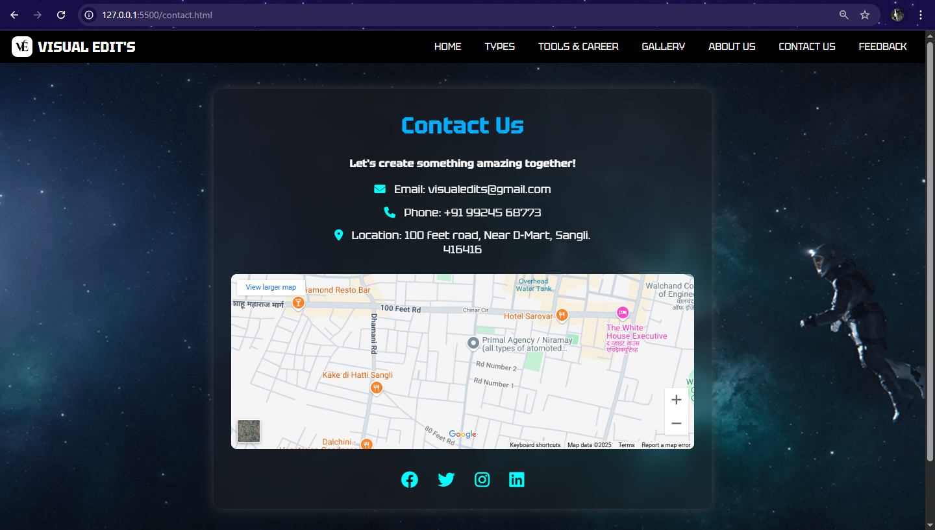

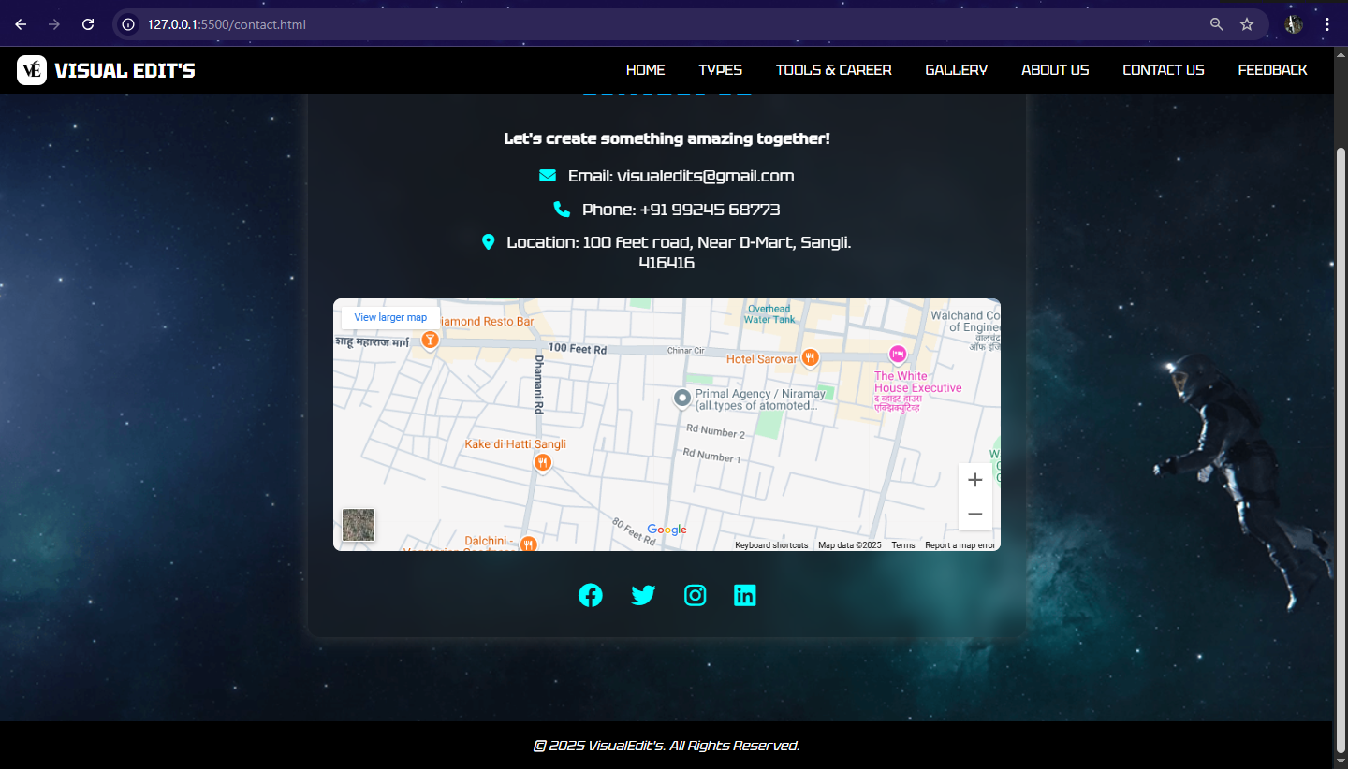

**Code : HTML & CSS**

<!DOCTYPE html>

<html lang="en">

<head>

    <meta charset="UTF-8">

    <meta name="viewport" content="width=device-width, initial-scale=1.0">

    <title>Contact Us</title>

    <link rel="preconnect" href="https://fonts.googleapis.com">

    <link rel="preconnect" href="https://fonts.gstatic.com" crossorigin>

    <link href="https://fonts.googleapis.com/css2?family=Tektur:wght@400..900&display=swap" rel="stylesheet">

    <link rel="stylesheet" href="https://cdnjs.cloudflare.com/ajax/libs/font-awesome/6.4.2/css/all.min.css">

    <style>

        body {

            margin: 0;

            background: url('contact.png') no-repeat center center fixed;

            background-size: cover;

            font-family: 'Tektur';

            text-align: center;

            background-color: #181818;

            color: #fff;

            scroll-behavior: smooth;

        }

        header {

            display: flex;

            justify-content: space-between;

            align-items: center;

            top: 0%;

            padding: 10px 20px;

            position: fixed;

            width: 98%;

            z-index: 10;

            background-color: #000000;

        }

        .logo {

            display: flex;

            align-items: center;

            justify-content: center;

        }

        .logo span {

            font-size: 24px;

            font-weight: bold;

            margin-left: 10px;

        }

        .logo img {

            height: 35px;

            width: auto;

            border-radius: 10px;

        }

        nav ul {

            list-style: none;

            padding: 0;

            margin: 0;

            display: flex;

        }

        nav ul li {

            margin: 0 10px;

        }

        nav ul li a {

            font-size: 17px;

            text-decoration: none;

            color: #fff;

            background: #000000;

            padding: 5px 10px;

            border-radius: 7px;

        }

        nav ul li a:hover {

            background: #fffefe;

            color: #0004ff;

        }

        .container {

            width: 50%;

            margin: 100px auto;

            padding: 30px;

            padding-top: 10px;

            background: rgba(43, 43, 43, 0.3);

            border-radius: 15px;

            box-shadow: 0px 0px 20px rgba(70, 71, 71, 0.8);

            backdrop-filter: blur(10px);

        }

        h1 {

            font-size: 2.5em;

            color: rgb(0, 174, 255);

        }

        .contact-info {

            margin-top: 20px;

        }

        .contact-info p {

            margin: 15px 0;

            font-size: 1.2em;

            transition: transform 0.3s ease-in-out;

        }

        .contact-info p:hover {

            transform: scale(1.1);

        }

        .contact-info i {

            margin-right: 10px;

            color: cyan;

        }

        .social-icons {

            margin-top: 30px;

        }

        .social-icons a {

            margin: 0 15px;

            font-size: 1.8em;

            color: cyan;

            transition: transform 0.3s, color 0.3s;

        }

        .social-icons a:hover {

            transform: scale(1.2);

            color: white;

        }

        @media (max-width: 768px) {

            .container {

                width: 80%;

                padding: 20px;

            }

        }

        footer {

            padding: 3px;

            background-color: black;

            position: relative;

            bottom: 0;

            width: 99.5%;

        }

    </style>

</head>

<body>

    <header>

        <div class="logo">

            <img src="LOGO.png" alt="Visual Edit's Logo">

            <span>VISUAL EDIT'S</span>

        </div>

        <nav>

            <ul>

                <li><a href="index.html">HOME</a></li>

                <li><a href="types.html">TYPES</a></li>

                <li><a href="tools&career.html">TOOLS & CAREER</a></li>

                <li><a href="gallery.html">GALLERY</a></li>

                <li><a href="about.html">ABOUT US</a></li>

                <li><a href="contact.html">CONTACT US</a></li>

                <li><a href="feedback.php">FEEDBACK</a></li>

            </ul>

        </nav>

    </header>

    <div class="container">

        <h1>Contact Us</h1>

        <p>

        <h3>Let's create something amazing together!</h3>

        </p>

        <div class="contact-info">

            <p><i class="fa-solid fa-envelope"></i> Email: visualedits@gmail.com</p>

            <p><i class="fa-solid fa-phone"></i> Phone: +91 9924568773</p>

            <p><i class="fa-solid fa-map-marker-alt"></i> Location: 100 feet road, Near D-Mart, Sangli.<br>416416</p>

        </div>

        <div class="map-container" style="margin-top: 30px;">

            <iframe

                src="https://www.google.com/maps/embed?pb=!1m18!1m12!1m3!1d3783.222425634991!2d74.59200917510296!3d16.843708983993077!2m3!1f0!2f0!3f0!3m2!1i1024!2i768!4f13.1!3m3!1m2!1s0x3bc11db7ffb8f733%3A0x41b08318859d25b!2sD%20Mart%2C%20100%20Feet%20Road%2C%20Sangli%2C%20Maharashtra%20416416!5e0!3m2!1sen!2sin!4v1712219014202!5m2!1sen!2sin"

                width="100%" height="300" style="border:0; border-radius: 10px;" allowfullscreen="" loading="lazy"

                referrerpolicy="no-referrer-when-downgrade">

            </iframe>

        </div>

        <div class="social-icons">

            <a href="#"><i class="fa-brands fa facebook"></i></a>

            <a href="#"><i class="fa-brands fa-twitter"></i></a>

            <a href="#"><i class="fa-brands fa-instagram"></i></a>

            <a href="#"><i class="fa-brands fa-linkedin"></i></a>

        </div>

    </div>

    <footer>

        <p><i>&copy 2025 VisualEdit's. All Rights Reserved.</i></p>

    </footer>

</body>

</html>

**FEEDBACK**

**feedback.php**

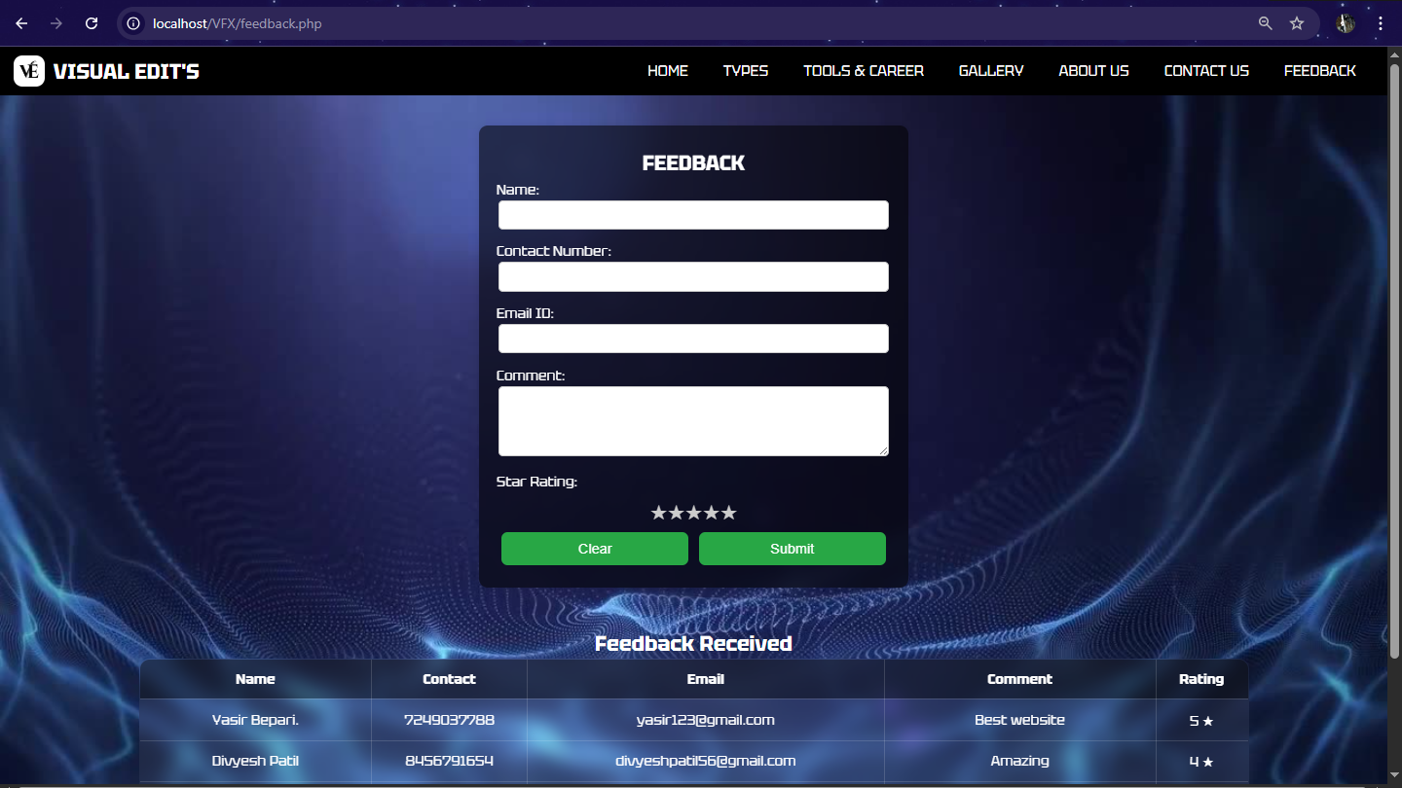

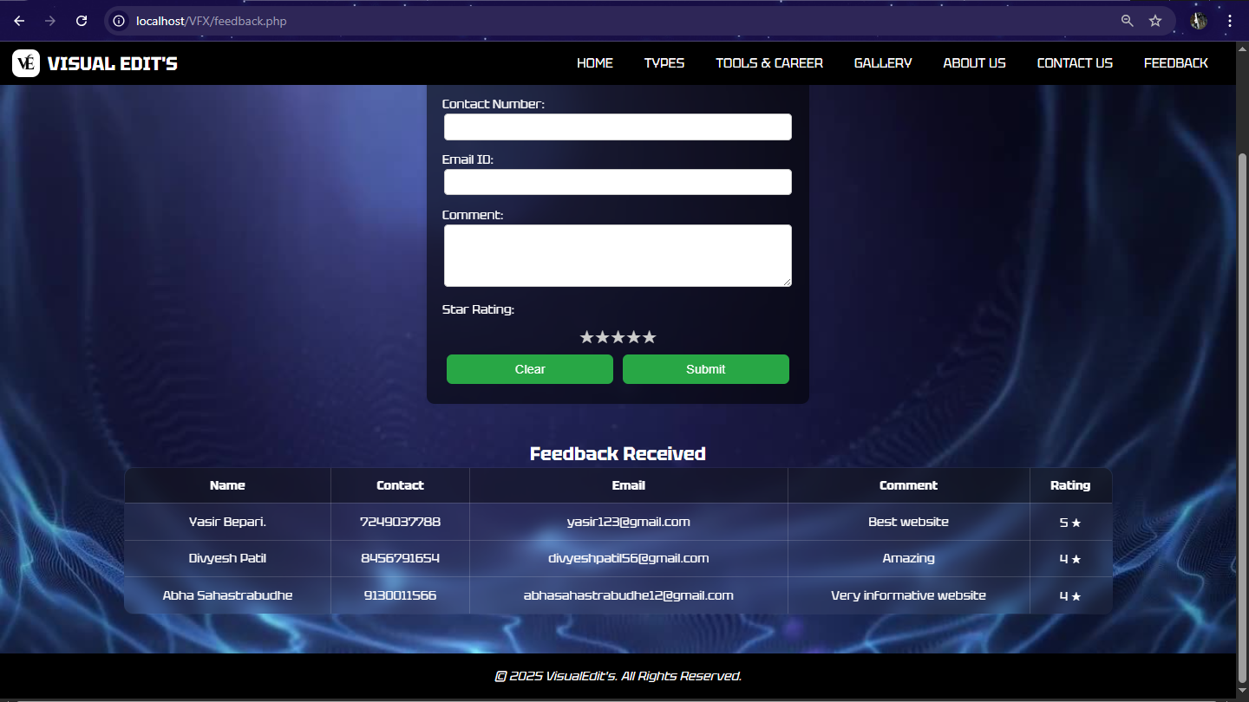

**Code : HTML, CSS, JavaScript & PHP**

<?php

$con = new mysqli('localhost', 'root', '', 'visualedit_feedback');

if ($con->connect_error) {

  die("Connection failed: " . $con->connect_error);

}

if ($_SERVER["REQUEST_METHOD"] == "POST") {

  $name = $con->real_escape_string($_POST['name']);

  $contact = $con->real_escape_string($_POST['contact']);

  $email = $con->real_escape_string($_POST['email']);

  $comment = $con->real_escape_string($_POST['comment']);

  $rating = $con->real_escape_string($_POST['rating']);

  $sql_insert = "INSERT INTO feedback (name, contact, email, comment, rating) VALUES ('$name', '$contact', '$email', '$comment', '$rating')";

  if (!$con->query($sql_insert)) {

    echo "<script>alert('Error submitting feedback: " . $con->error . "');</script>";

  } else {

    echo "<script>alert('Feedback submitted successfully!');</script>";

  }

}

$sql = "SELECT * FROM feedback";

$result = $con->query($sql);

?>

<!DOCTYPE html>

<html lang="en">

<head>

  <meta charset="UTF-8" />

  <meta name="viewport" content="width=device-width, initial-scale=1.0" />

  <title>Feedback</title>

  <link rel="preconnect" href="https://fonts.googleapis.com" />

  <link rel="preconnect" href="https://fonts.gstatic.com" crossorigin />

  <link href="https://fonts.googleapis.com/css2?family=Tektur:wght@400..900&display=swap" rel="stylesheet" />

  <style>

    body {

      margin: 0;

      height: 100vh;

      display: flex;

      flex-direction: column;

      align-items: center;

      background: url('fd2.jpg') no-repeat center center fixed;

      background-size: cover;

      font-family: 'Tektur';

      text-align: center;

      background-color: #181818;

      color: #fff;

      scroll-behavior: smooth;

    }

    header {

      position: fixed;

      top: 0;

      width: 98%;

      background-color: #000000;

      padding: 10px 20px;

      display: flex;

      justify-content: space-between;

      align-items: center;

      z-index: 10;

    }

    .logo {

      display: flex;

      align-items: center;

      justify-content: center;

    }

    .logo span {

      font-size: 24px;

      font-weight: bold;

      margin-left: 10px;

    }

    .logo img {

      height: 35px;

      width: auto;

      border-radius: 10px;

    }

    nav ul {

      list-style: none;

      padding: 0;

      margin: 0;

      display: flex;

    }

    nav ul li {

      margin: 0 10px;

    }

    nav ul li a {

      font-size: 17px;

      text-decoration: none;

      color: #fff;

      background: #000000;

      padding: 5px 10px;

      border-radius: 7px;

    }

    nav ul li a:hover {

      background: #fffefe;

      color: #0004ff;

    }

    .container {

      background: rgba(0, 0, 0, 0.555);

      backdrop-filter: blur(8px);

      padding: 20px;

      margin-top: 90px;

      border-radius: 10px;

      box-shadow: 0px 0px 10px rgba(0, 0, 0, 0.1);

      height: auto;

      width: 450px;

      text-align: center;

    }

    h2 {

      margin-top: 7px;

      margin-bottom: 3px;

      color: #ffffff;

    }

    label {

      color: white;

      display: block;

      text-align: left;

      margin: 5px 0 2px;

    }

    input,

    textarea {

      width: 95%;

      padding: 8px;

      margin-bottom: 10px;

      border: 1px solid #ccc;

      border-radius: 5px;

    }

    .star-rating {

      display: flex;

      justify-content: center;

      flex-direction: row-reverse;

    }

    .star-rating input {

      display: none;

    }

    .star-rating label {

      font-size: 24px;

      color: #ccc;

      cursor: pointer;

      transition: color 0.3s;

    }

    .star-rating input:checked~label,

    .star-rating label:hover,

    .star-rating label:hover~label {

      color: gold;

    }

    button {

      background: #28a745;

      color: white;

      border: none;

      padding: 10px;

      width: 90%;

      border-radius: 7px;

      cursor: pointer;

      font-size: 16px;

      margin: 6px;

      transition: transform 0.3s;

    }

    .button-group {

      display: flex;

      justify-content: space-between;

      width: 100%;

    }

    button:hover {

      background: #218838;

      transform: scale(1.1);

    }

    footer {

      bottom: 0;

      display: flex;

      justify-content: center;

      align-items: center;

      padding: 3px;

      margin-top: 50px;

      background-color: black;

      width: 100%;

    }

    table {

      width: 80%;

      border-collapse: collapse;

      background: rgba(255, 255, 255, 0.05);

      backdrop-filter: blur(10px);

      border-radius: 12px;

      overflow: hidden;

      border: 1px solid rgba(255, 255, 255, 0.1);

    }

    th,

    td {

      padding: 12px;

      text-align: center;

      border: 1px solid rgba(255, 255, 255, 0.15);

    }

    th {

      background-color: rgba(0, 0, 0, 0.4);

      font-weight: bold;

    }

  </style>

</head>

<body>

  <header>

    <div class="logo">

      <img src="LOGO.png" alt="Visual Edit's Logo">

      <span>VISUAL EDIT'S</span>

    </div>

    <nav>

      <ul>

        <li><a href="index.html">HOME</a></li>

        <li><a href="types.html">TYPES</a></li>

        <li><a href="tools&career.html">TOOLS & CAREER</a></li>

        <li><a href="gallery.html">GALLERY</a></li>

        <li><a href="about.html">ABOUT US</a></li>

        <li><a href="contact.html">CONTACT US</a></li>

        <li><a href="feedback.php">FEEDBACK</a></li>

      </ul>

    </nav>

  </header>

  <div class="container">

    <h2>FEEDBACK</h2>

    <form id="feedbackForm" action="feedback.php" method="POST">

      <label for="name">Name:</label>

      <input type="text" id="name" name="name" required>

      <label for="contact">Contact Number:</label>

      <input type="tel" id="contact" name="contact" pattern="[0-9]{10}" required>

      <label for="email">Email ID:</label>

      <input type="email" id="email" name="email" required>

      <label for="comment">Comment:</label>

      <textarea id="comment" name="comment" rows="4" required></textarea>

      <label>Star Rating:</label>

      <div class="star-rating">

        <input type="radio" id="star5" name="rating" value="5"><label for="star5">★</label>

        <input type="radio" id="star4" name="rating" value="4"><label for="star4">★</label>

        <input type="radio" id="star3" name="rating" value="3"><label for="star3">★</label>

        <input type="radio" id="star2" name="rating" value="2"><label for="star2">★</label>

        <input type="radio" id="star1" name="rating" value="1"><label for="star1">★</label>

      </div>

      <div class="button-group">

        <button type="reset">Clear</button>

        <button type="submit">Submit</button>

      </div>

    </form>

  </div>

  <br><br>

  <h2>Feedback Received</h2>

  <table>

    <thead>

      <tr>

        <th>Name</th>

        <th>Contact</th>

        <th>Email</th>

        <th>Comment</th>

        <th>Rating</th>

      </tr>

    </thead>

    <tbody>

      <?php

      if ($result->num_rows > 0) {

        while ($row = $result->fetch_assoc()) {

          echo "<tr>

                      <td>" . htmlspecialchars($row['name']) . "</td>

                      <td>" . htmlspecialchars($row['contact']) . "</td>

                      <td>" . htmlspecialchars($row['email']) . "</td>

                      <td>" . htmlspecialchars($row['comment']) . "</td>

                      <td>" . $row['rating'] . " ★</td>

                    </tr>";

        }

      } else {

        echo "<tr><td colspan='6'>No feedback found.</td></tr>";

      }

      ?>

    </tbody>

  </table>

  <footer>

    <p><i>&copy; 2025 VisualEdit's. All Rights Reserved.</i></p>

  </footer>

</body>

</html>

**4.1 Navigation of Website:**

**Home**



**Home 🡪 Types**



**Home 🡪 Tools & Carrer**



**Home 🡪 Gallery**



**Home 🡪 About Us**



**Home 🡪 Contact Us**



**Home 🡪 Feedback**



* 1. **User Manual:**

|  |  |  |
| --- | --- | --- |
| **Sr. No.** | **Menu** | **Description** |
| **1)** | **Home** | **The Home Tab serves as the main page and provides a brief overview of the website purpose and content, offering quick navigation to other sections.** |
| **2)** | **Types** | **The Types Tab provides detailed information about the various types of VFX & CGI. Users can explore different categories such as compositing, 3D modeling, motion capture and more, gaining a clear understanding of their importance in the VFX & CGI industry.** |
| **3)** | **Tools & Career** | **The Tools & Career Tab provide widely used tools and software in the VFX & CGI industry, such as Adobe After Effects, Blender, Maya, Nuke, and more. Additionally, it provides guidance on career options/job roles, required skills, and opportunities available in the field.** |
| **4)** | **Gallery** | **The Gallery Tab showcases a collection of images related to VFX & CGI work. It includes samples of effects, before-and-after transformations, creative projects, etc.** |
| **5)** | **About Us** | **The About Us Tab provides information about the website and mission and goals of the website & organization.** |
| **6)** | **Contact Us** | **The Contact Us Tab provide contact details of the organization, including email address, phone number, and location.** |
| **7)** | **Feedback** | **In Feedback Tab user can give reviews, and suggestions. It helps new visitors understand the website.** |

**6.1 Conclusion & Further Enhancement:**

Conclusion:

The VFX and CGI website serves as a comprehensive platform aimed at educating and inspiring individuals interested in the world of visual effects and computer-generated imagery. It provides detailed insights into industry-standard tools, career paths, educational resources, and project showcases. By bridging the gap between curiosity and professional knowledge, the platform empowers students, hobbyists, and aspiring professionals to explore and grow in the creative tech industry.

Future Enhancements:

To further improve the user experience and expand the website’s capabilities, several future enhancements are planned:

1. Interactive Tutorials & Courses:

Add step-by-step tutorials and online courses with interactive elements for Blender, Maya, Unreal Engine, and more.

2. Community Forum:

Introduce a community space where users can discuss, share work, get feedback, and collaborate on projects.

3. Portfolio Section for Users:

Allow users to create profiles and showcase their VFX/CGI work to gain visibility and networking opportunities.

4. Job & Internship Listings:

Integrate a job board for internships, freelance gigs, and job openings in the VFX/CGI industry.

5. AI-Powered Learning Path Suggestions:

Use AI to recommend personalized learning paths based on user interests and skill level.

6. Mobile App Version:

Develop a mobile application for easier access and learning on-the-go.

7. Regular Webinars & Expert Talks:

Host sessions with professionals in the industry to give learners firsthand knowledge and updates on current trends.

**7.1 Bibliography:**

**Books Referred:**

* **Complete HTML – Thomas Powell**
* **HTML BlackBook – Steven Holzner**
* **Learning Web Design- Jennifer Niederst Robbins**

**Website Referred:**

* [**https://www.w3schools.com/**](https://www.w3schools.com/)
* [**https://www.google.com/**](https://www.google.com/)
* [**https://www.youtube.com/**](https://www.youtube.com/)